**Project Design Phase**

**Solution Architecture**

|  |  |
| --- | --- |
| Date | 15 February 2025 |
| Team ID | LTVIP2025TMID32163 |
| Project Name | Smart SDLC – AI Enhanced Software Development Lifecycle |
| Maximum Marks | 4 Marks |

### ****Solution Architecture: Smart SDLC****

**Objective:**  
To bridge the gap between complex software development processes and accessible, AI-powered guidance for developers and learners.

### ****Key Components:****

* **Frontend Interface:**  
  Intuitive UI for interacting with users across SDLC phases, built using modern web frameworks (e.g., React or minimal UI via FastAPI).
* **Backend Engine (FastAPI):**  
  Lightweight, high-performance Python framework handling user requests, session states, and orchestration of AI responses.
* **AI Model Integration:**  
  IBM Granite-3.3-2b-instruct model provides generative responses tailored to each SDLC phase—requirement analysis, design, development, testing, deployment, and maintenance.
* **Phase-wise Logic Layer:**  
  Business logic that maps user inputs and project context to relevant SDLC stages, guiding decision-making intelligently.
* **Data Layer (optional for scalability):**  
  Stores project history, user preferences, or learning paths to personalize the experience.

### ****Architecture Goals:****

✅ Deliver contextual, real-time support for each SDLC phase  
✅ Enable modular feature expansion (e.g., plug-in DevOps or test automation)  
✅ Ensure scalability for individual, institutional, or enterprise use  
✅ Provide an explainable AI layer to maintain trust and clarity in responses

**Example - Solution Architecture Diagram:**

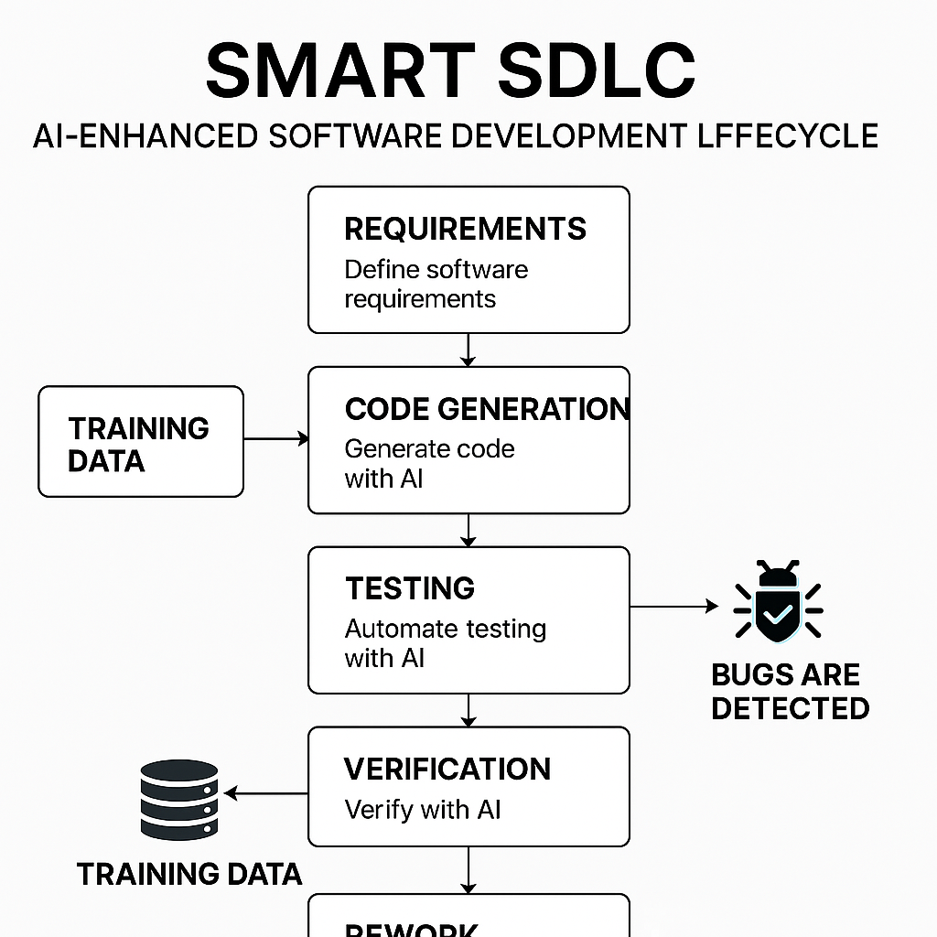

*Figure 1: Architecture and data flow of the voice patient diary sample application*

**Reference:** [**https://aws.amazon.com/blogs/industries/voice-applications-in-clinical-research-powered-by-ai-on-aws-part-1-architecture-and-design-considerations/**](https://aws.amazon.com/blogs/industries/voice-applications-in-clinical-research-powered-by-ai-on-aws-part-1-architecture-and-design-considerations/)